Try different features and algorithms

Some of you have already a working model after the previous assignment, and some still have not completed that. For the next deadline, I would like to see some results from your models. So, what I need is really an evaluation of your working model using the evaluation metrics that make sense for your task, this includes accuracy, Precision, Recall, F1, or maybe something specific for your task if these metrics do not work for you.

Some of you implement one algorithm, but for the projects which use tools, evaluate your features try a few different learning algorithms.

Describe what algorithms and via which tools you have used.  Evaluate various models and report performance of your model on your test data. You can provide the evaluation of your test data or use cross-validation. Please be communicative about it and let me know what is your approach to improving your initial results. Post your main test results on canvas and codes on your GitHub repository.

Please find my code in [Link](https://github.com/peleonard/CMPS-4720-6720-Sp18/blob/master/project/s2s0417test.py).

The method applied is a sequence-to-sequence model that consists of couple of algorithms:

1. a stacked LSTM encoder and a stacked LSTM decoder

2. attentions mechanism in on the top of decoder to improve final output by using source LSTM

3. learning rate decay to quickly go to the minimum

4. adam optimizer and clipped gradient to optimize the gradient descent.

5. dropout method of LSTM to avoid overfitting.

They all can be applied to improve the training weights.

Following are two of my training results.

1.

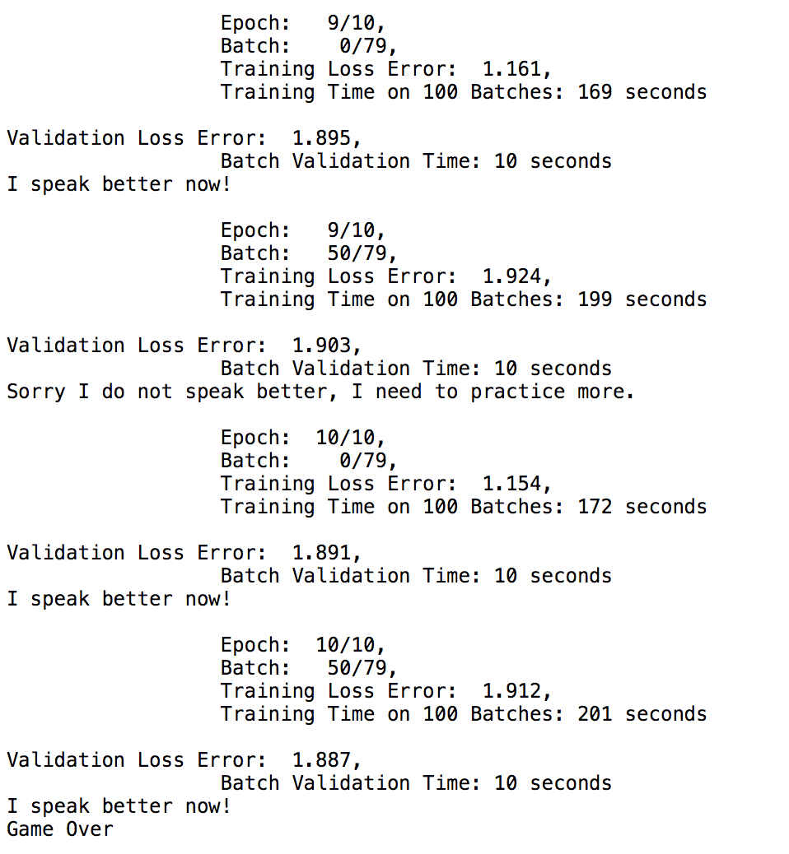

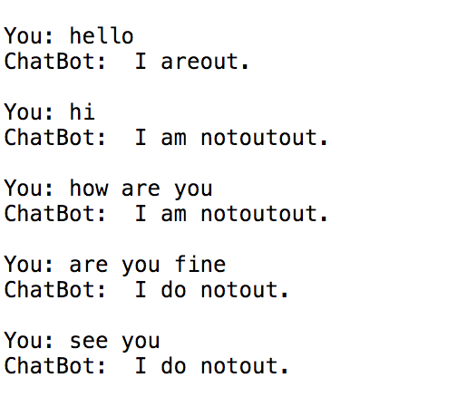

I just run 10 epochs on 1% of the original dataset. The results are very simple. And it will return a lot of “out”, since the vocabulary is small. (A lot of words are not covered.)

2. 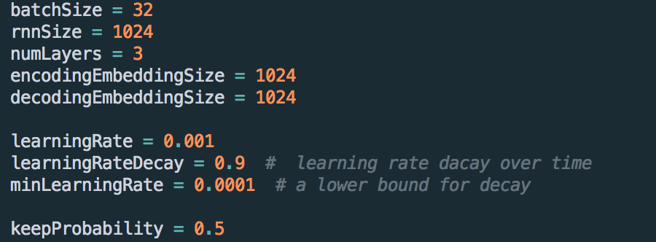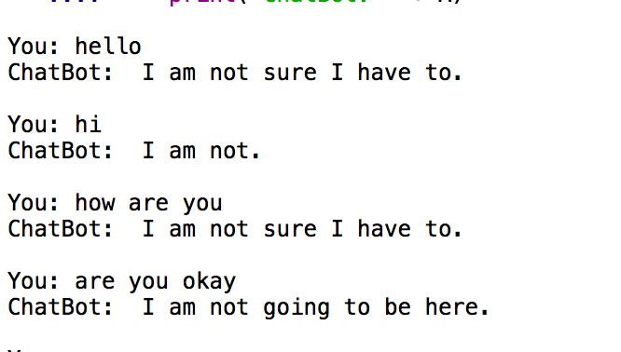

This result is on the whole dataset but only the run 2 epochs, with the hyperparameters above. It can be seen the result is somehow more reasonable.

I am still trying to get more powerful GPU resource. I hope I can get much more meaningful result.